**EXPERIMENT-7**

**DATE:30-09-2025**

**AIM:**

To create a virtual machine with 1 cpu, 2gb ram and 15gb storage disk using a type 2 virtualization software**.**

**PROCEDURE:**

**STEP 1:** Download VMware workstation and installed as type 2 hypervisor.

**STEP2:** Download ubuntu or tiny OS as iso image file.

**STEP 3:** In VMware workstation->create new VM.

**STEP 4:** Do the basic configuration settings.

**STEP 5:** Created tiny OS virtual machine.

**STEP 6:** Launch the VM.

IMPLEMENTATION:

**STEP 1: DOWNLOAD VMWARE WORKSTATION AND INSTALLED AS TYPE 2 HYPERVISOR**

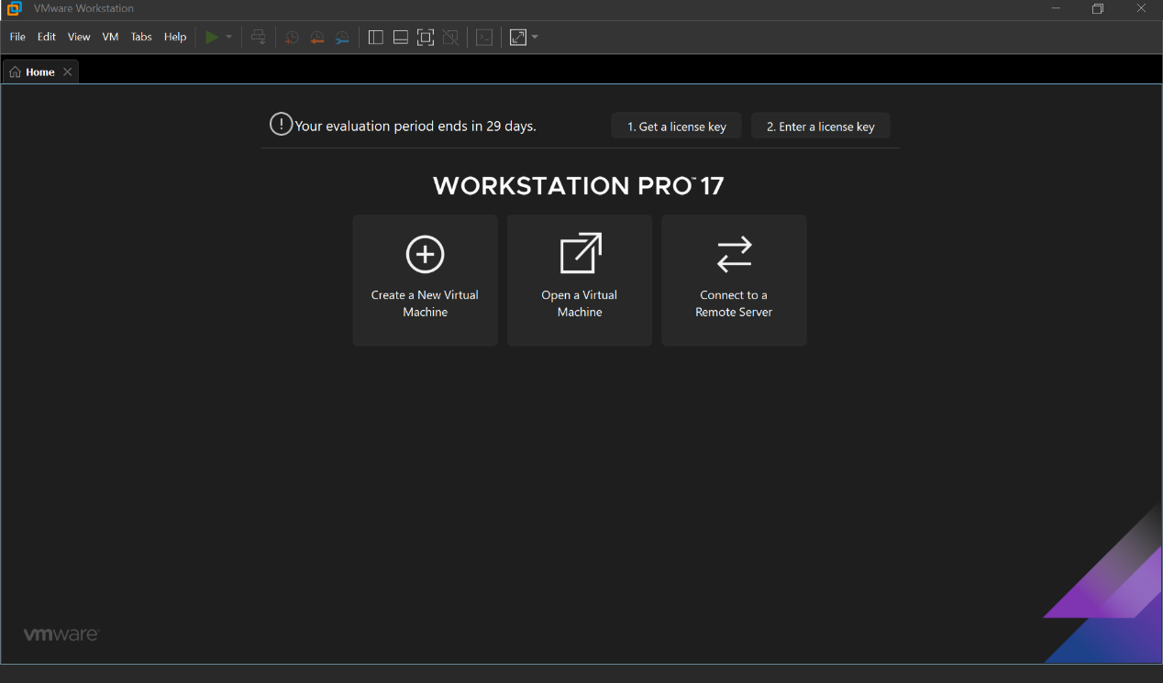

**STEP2: DOWLOAD UBUNTU OR TINY OS AS ISO IMAGE FILE**

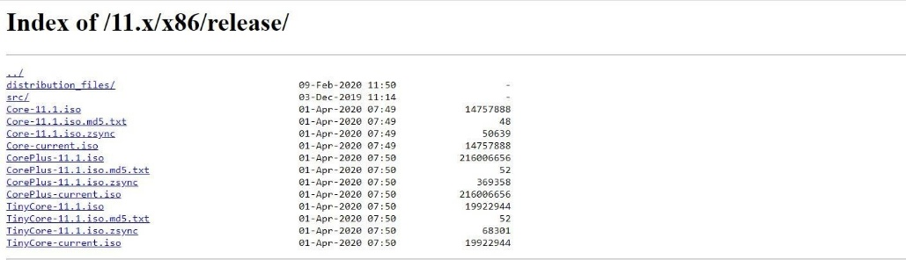

**STEP 3: IN VMWARE WORKSTATION->CREATE NEW VM** 

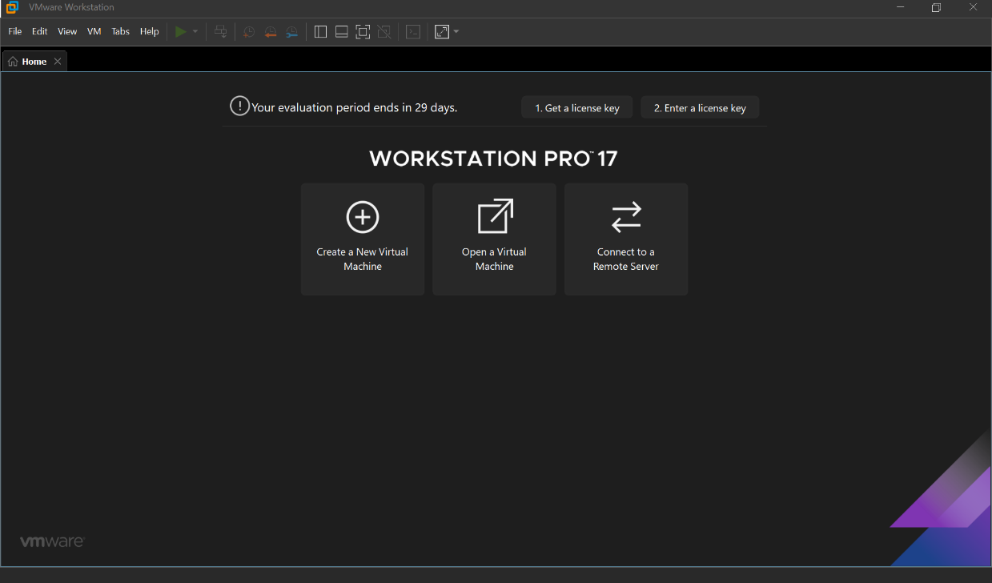

**STEP 4: DO THE BASIC CONFIGURATION SETTINGS.**

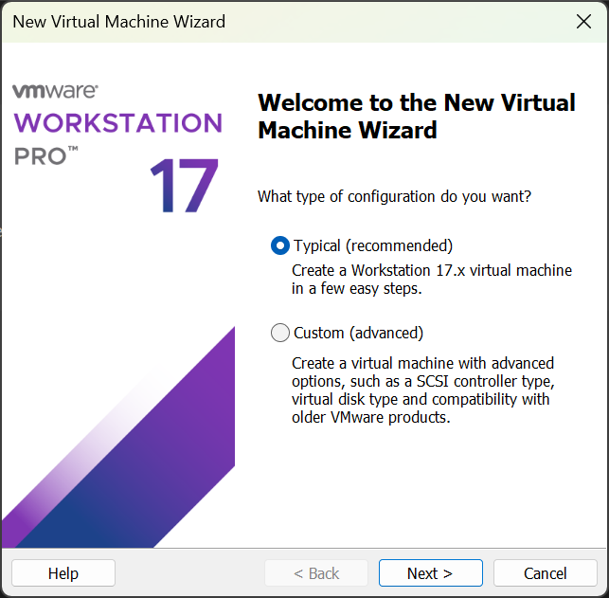

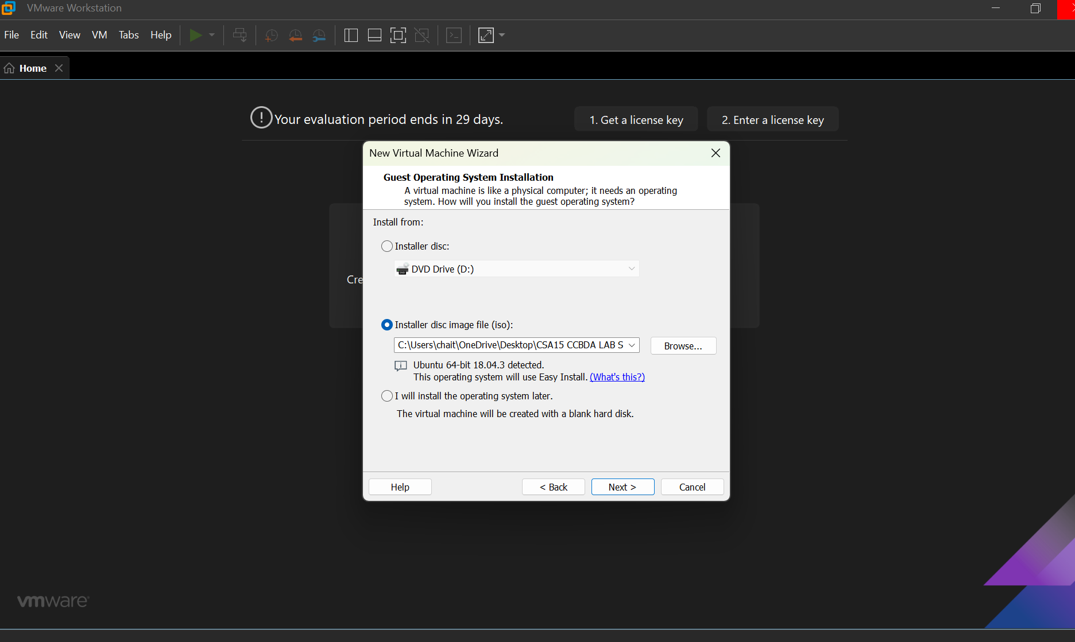



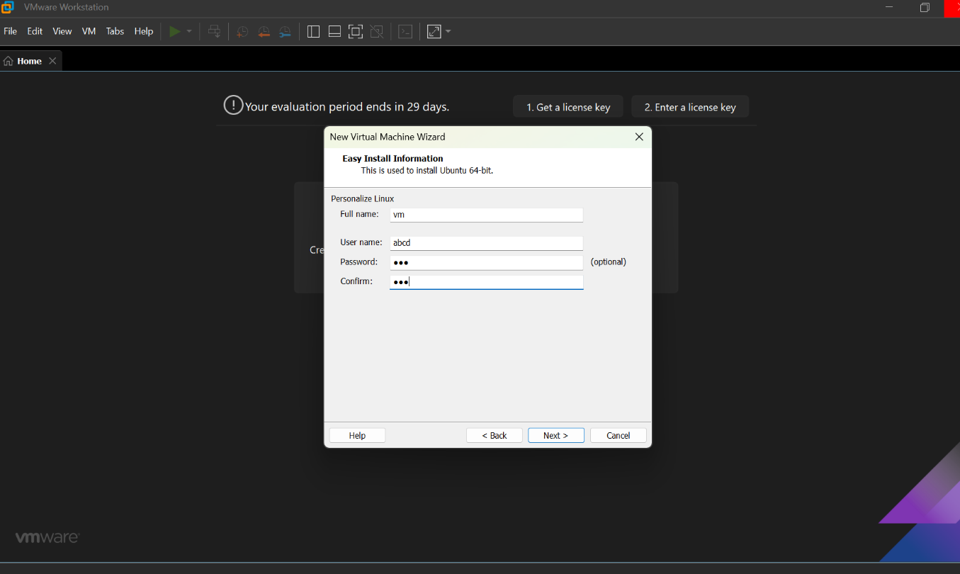

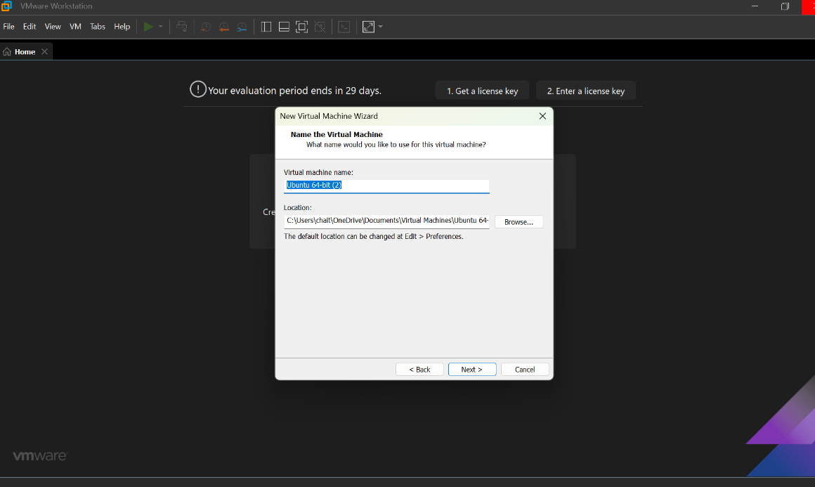

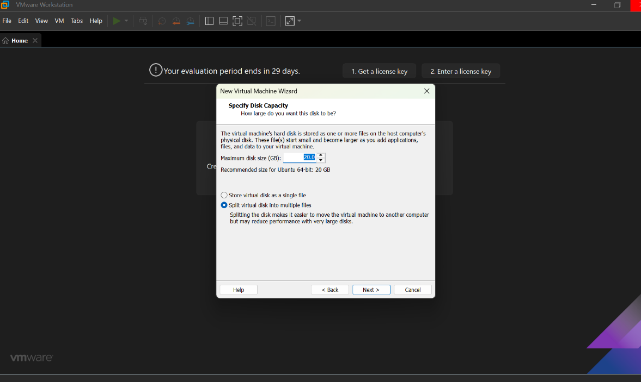

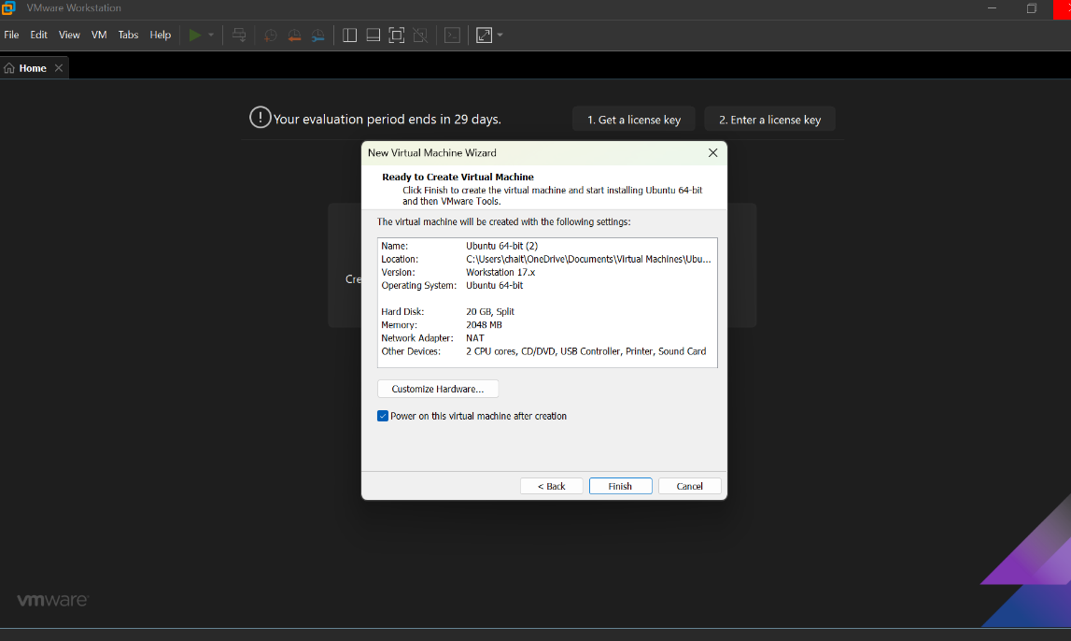

**STEP 5: CREATED TINYOS VIRTUAL MACHINE**

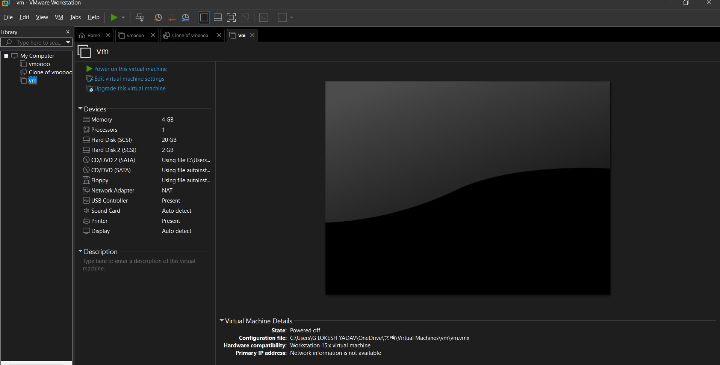

**RESULTS;** successfully created a virtual machine with 1 cpu, 2gb ram and 15gb storage disk using a type 2 virtualization software**.**